The John Eliot Style 1770
Philadelphia Chippendale Stool Class

Ray Journigan

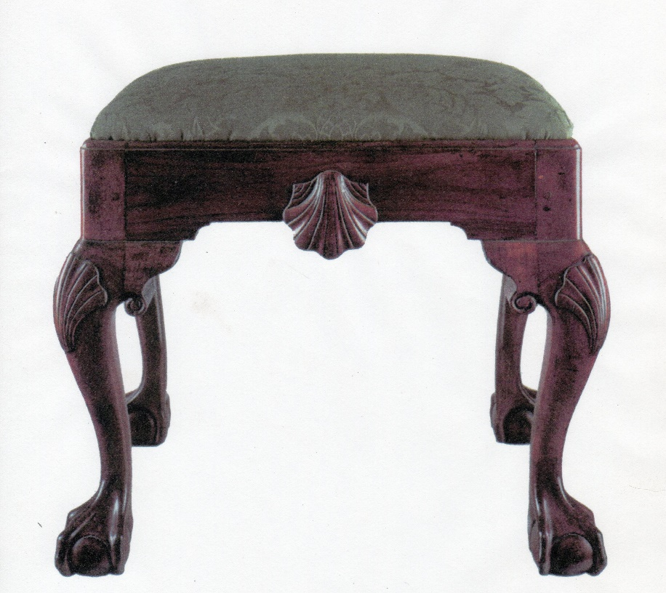
A foot stool is a great way to gain skills using your hand tools. This useful piece of furniture can be used to rest the feet after a long day or as a sitting stool for that last arriving guest. And the “John Elliot” footstool is one of the finest examples made in the 18th century. There is a lot a skills in this little project. After surfacing our materials with a hand plane, Ray will demonstrate different methods of laying out and cutting mortise and tenon joints by hand using tools such as a mortise gauge, tenon saw, mortise chisel, bench chisel, shoulder plane and router plane. Next, he will demonstrate cutting and shaping cabriole legs using spokeshaves, rasps, files, and card scrapers. Then Ray will demonstrate an uncomplicated way to layout and carve a Philadelphia style ball and claw foot. And if that wasn’t enough, Ray will teach you how to layout and carve scallop shells both in the round, like those found on the knees of each leg, and as an applique which a placed on the aprons. This class is designed so you can take your woodworking skills to the next level without having to empty your wallet for materials. Other subject that will be discussed include tool sharpening, small shop organization for efficiency, and finishing techniques just to name a few!
Students will be expected to complete all the joinery and all the carving for at least one foot. Some will accomplish more depending on skill level and time committed. All the skill necessary will be learned so the project can be competed at home.

Tool List:
You are encouraged to bring your general woodworking tools along with the following
for the Stool Class:
5/16” Mortise Chisel
¼”, ½”, ¾”, 1” bench Chisels (If you have them)
Mallet
6” or larger Rule
Combination Square
Tenon or Dovetail saw
#49 or 50 Nicholson rasp or equivalent
10” Med cut cabinet file
8” Smooth cut wood file
Spokeshave
Square card scraper
Smooth plane
Block Plane
Shoulder Plane
Compass

Carving:
You are encouraged to bring your carving roll with chisels to include the following:
15/6mm v tool 7/14mm gouge (fishtail)
2/12mm gouge 8/3mm gouge
2/30mm gouge 8/7mm gouge
5/8mm gouge (fishtail) 8/10mm gouge
5/12mm gouge (fishtail) 8/13mm gouge
5/25mm gouge 25/10mm Backbend gouge
7/6mm gouge (fishtail)
7/10mm gouge (fishtail)

Materials
Primary Wood – Mahogany Recommended; Walnut, Cherry, Maple are OK too but harder to carve
Legs @ 12/4” x 12/4” x 24” (This includes material for Knee blocks)
2 Aprons @ 4/4” x 4” x 20”
2 Aprons @ 4/4” x 4” x 14”
2 Shells @ 4/4” x 4” x 4”
2 Shell Backers @ 4/4” x 1 1/8” x 4”
Secondary Wood: Poplar or Pine (Slip seat)
2 Rails @ 4/4” x 2 ¾” x 20”
2 Stiles @ 4/4” x 2 ¾” x 12”

